

 

*I*

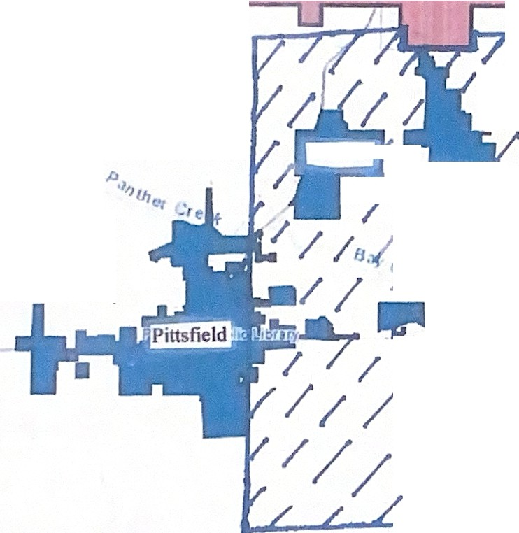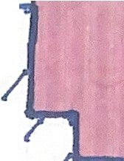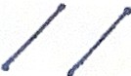

r

Nort11fike J?i "i.c. Library

Pittsfield

/

/ .

/

i--

**Pittsfield**

/

/

*I*

'

I

*-l(•j*

f

I

*L/*

•

*I*



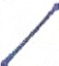



Territory to be Annexed: aJI of the unserved territory in Newburg own..hip .....

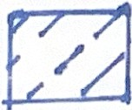I (excepting tl1at part within the No11h Pike Di trict L1br8f)) within the •

bo'undaries oftl1e Pikeland CUSD No. 10, in Pike County. [llinois

•

* '

•